**Experiment No: 6**

**Applying DML commands on Road Way Travels Tables. Data Manipulation Comman**

**Query:**

use testdb;

create table student_details(roll_no int, student_name varchar(100), branch char(3));

desc student_details;

alter table student_details

add primary key(roll_no);

desc student_details;

#Insert

insert into student_details values(1, 'Rachana', 'cse');

insert into student_details values(2, 'Nitisha', 'cse');

insert into student_details values(3, 'jdfgnjh', 'cse');

select * from student_details;

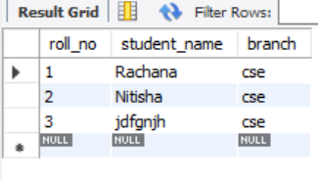

#Update

update student_details

set student_name = 'Mounika'

where roll_no = 3;

select * from student_details;

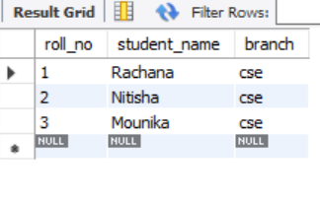

#Delete

delete from student_details where roll_no = 2;

select * from student_details;

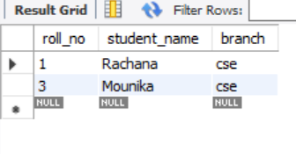

#Select

select student_name, roll_no from student_details;

